### Smart Stand-up wheelchair using

### Raspberry Pi and RF Controller

Mr Akash Patil

Mr Sujaykumar Wankhede

Mr Mangesh Bari

Guide name: Ms. Shital Jadhav

1Student, Department of Computer and Science Engineering, G H Raisoni Institute of Business Management. M. S, India

2Student, Department of Computer and Science Engineering, G.H.Raisoni Institute of Business Mangement, M. S, India.

3Student, Department of Computer and Science Engineering, G.H.Raisoni Institute of Business Management, M. S,India.

**ABSTRACT**

*Smart Stand-up wheelchair using Raspberry Pi and RF Controller is mechanically controlled devices designed to have self mobility with the help of the user command. This reduces the user’s human effort and force to drive the wheels for wheelchair .Furthermore it also provides an opportunity for visually or physically impaired persons to move from one place to another.*

*Smart wheelchair has gained a lot of interests in the recent times. These devices are useful especially in transportation from one place to another. The machines can also be used in old age homes where the old age persons have difficulty in their movements. The devices serve as a boon for those who have lost their mobility.*

# **1 INTRODUCTION**

Though the recent developments of science and technology has drastically changed the way a normal person lives his life , there are certain groups of people who have not been able to be benefit from this development. On particular handicapped people with have limited mobility are still living a miserable life.

A Smart Stand-up wheelchair using Raspberry Pi and RF Controller aims to provide aid to those handicapped and physically challenged persons by providing them with some sort of mobility which would greatly help them. Smart wheel chair consists of a major controller unit which allows the user to provide the input in the form of joystick or accelerometer or a voice command. The controller unit then synthesizes the command and takes required action so as to move the wheelchair to the particular position.

# **2 LITERATURESURVEY:**

|  |  |  |  |  |
| --- | --- | --- | --- | --- |
| Automated-Guided Wheelchair NEC Corporation, Japan |  | 1992 |  | Follows tracks laid out with magnetic ferrite marker tape. Uses IR sensors to stop when obstacles detected in its path. |
| Autonomous Wheelchair Arizona State University, U.S. |  | 1986 |  | Uses machine vision to identify landmarks and center wheelchair in hallway. |
| CHARHM CDTA, Algeria |  | 1996 |  | Chair navigates autonomously to location in environment based on internal map and information from machine vision. |
| COACH French Atomic Energy Commission, France |  | 1993 |  | Provides obstacle avoidance and follows walls. Unclear how active operating mode is chosen. |
| CWA (Manual) National University of Singapore, Singapore |  | 2002 |  | Uses dead reckoning to keep wheelchair on prescribed path. User can leave path to avoid obstacles, and controls speed of wheelchair along path. Path can be defined with GUI or by walkthrough. Torque sensors in pushrims sense user input. Small motorized wheels apply force to regular manual wheelchair wheels. http://guppy.mpe.nus.edu.sg/~eburdet |
| CWA (Power) National University of Singapore, Singapore |  | 2002 |  | Uses dead reckoning to keep wheelchair on prescribed path. User can leave path to avoid obstacles, and controls speed of wheelchair. Path can be defined with GUI or by walkthrough. http://guppy.mpe.nus.edu.sg/~eburdet |
| CCPWNS University of Notre Dame, U.S. |  | 1994-2000 |  | User can automatically reproduce routes taught to system by manually driving wheelchair from starting point to goal point. Uses machine vision to identify landmarks in environment. No obstacle avoidance mode. http://www.nd.edu/~ame/facultystaff/Skaar%2CSteven.html#SkaarResearch3 |
| Hephaestus TRAC Labs, U.S. |  | 1999-2002 |  | Provides obstacle avoidance. Compatible with multiple brands of wheelchairs and does not require any modifications to underlying power wheelchair. |
| INCH Yale University, U.S. |  | 1989 |  | Very early attempt that used small robot that drove like a wheelchair. Used sonar to avoid obstacles and drop-offs. |

**3 System Architecture:**

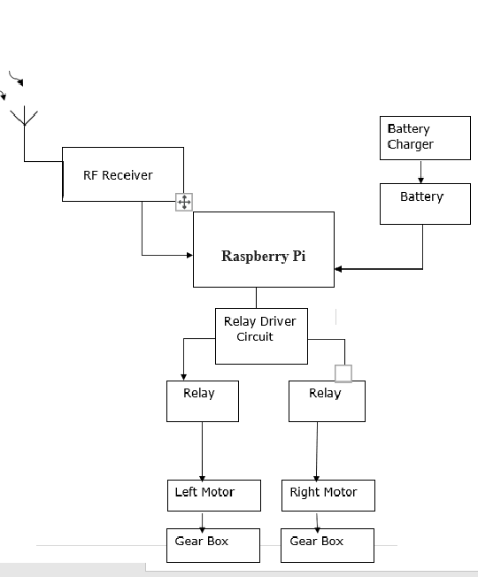

**Hardware Used:-**

**1** **Raspberry Pi :**

The Raspberry Pi is a low cost, credit-card sized computer that plugs into a computer monitor or TV, and uses a standard keyboard and mouse. It is a capable little device that enables people of all ages to explore computing, and to learn how to program in languages like Scratch and Python.

**2 Transmitter:** Transmitter The value we got in 3 axis accelerometer is depends upon the movement of hand and measuring it convert it in to digital with the help of ADC IC. Afterwards ADC converts the data from sensor and proceeds to the microcontroller

#### **3 Receiver:** Receiver circuit contains a RF receiver motor driving circuit and decoder circuit. Receiver got RF frequency transmitted from transmitter and provides this signal to HT12D decoder circuit. The output from the decoder circuit provide commands to motor driver circuit .To drive the motor wheels of the wheelchair H- bridge is used. Direction of the chair totally depends upon the signal received. The wheelchair can be moved forward backward, left and right by changing the position of head.

#### **4 Servo motor:** Servo motor is a specific type of motor that is combined with a rotary encoder or a potentiometer to form a servomechanism. This assembly may in turn form part of another servomechanism. A potentiometer provides a simple analog signal to indicate position, while an encoder provides position and usually speed feedback, which by the use of a PID controller allow more precise control of position and thus faster achievement of a stable position (for a given motor power). Potentiometers are subject to drift when the temperature changes whereas encoders are more stable and accurate

**CONCLUSIONS:**

Our project was the complete combination of the electronic circuits, the hardware& software knowledge.Automatic wheelchair can be used to handicapped people, especially those who are not able to move.The system is successfully run to move the wheelchair left, Right, Forward, Backward or Stay in same position.

**ACKNOWLEDGEMENT**:-

We express our sincere thankfulness to our Project Guide Ms.Shital Jadhav and our Head of the Department Ms. Sonal Patil for the successful guidance to our project. Without the help it would be tough job for us to accomplish this task. We thank our guide for her consistent guidance, encouragement and motivation throughout our period of work. We thank our HOD Mam for providing us all the necessary facilities.

# **REFERENCES:**

* Murarka, M. Sridharan and B. Kuipers. 2008. “Detecting obstacles and drop- offs using stereo and motion cues for safe local motion”.IEEE/RSJ International Conference on Intelligent Robots and Systems (IROS- 08).
* ShilpaGulati, Benjamin Kuipers2008. “High Performance Control for Graceful Motion of an Intelligent Wheelchair”.Proceedings of the IEEE International Conference on Robotics and Automation (ICRA).
* Srishti, Shalu, Prateeksha Jain, “The Smart Wheelchair Using Head Gesture Control”, International Journal of Advanced Engineering Science and Technological Research, vol.3, Issue 1 March 2015,ISSI 2321-1202.
* ShreedeepGangopadhy., SomsubraMukherjee, Soumya Chatterjee, “Intelligent Gesture Controlled Wireless Wheelchair For The Physically Handicapped”, Proceedings of Fifth IRAJ International Conference, Pune, India,Vol.1,No.7,pp.47-52, 15 September 2013.
* MoniruzzamanBhuiyan, Rich Picking, “A Gesture Controlled User Interface For Inclusive Design And Evaluation Study Of Its Usability”, Journal of Software Engineering and Applications,Vol.4, No.9,pp.513-521,September 2